Part Number: PT908-08170-02

Kit Contents

|  |  |  |
| --- | --- | --- |
| Item # | Quantity Reqd. | Description |
| 1 | 1 | Front Driver Liner  (with warning tag installed) |
| 2 | 1 | Front Passenger Liner |
| 3 | 1 | 2nd Row Driver Side Mat |
| 4 | 1 | 2nd Row Passenger Side Mat |
| 5 | 1 | 2nd Row Center Mat |
| 6 | 1 | Aisle Mat |
| 7 | 1 | 3rd Row Driver Side Mat |
| 8 | 1 | 3rd Row Passenger Side Mat |

Hardware Bag Contents

|  |  |  |
| --- | --- | --- |
| Item # | Quantity Reqd. | Description |
|  |  |  |
|  |  |  |

Additional Items Required For Installation

|  |  |  |
| --- | --- | --- |
| Item # | Quantity Reqd. | Description |
|  |  |  |
|  |  |  |

Conflicts

|  |
| --- |
| Not intended for Mobility vans |

Recommended Tools

|  |  |
| --- | --- |
| Personal & Vehicle Protection | Notes |
| None |  |
|  |  |
| Special Tools | Notes |
| None |  |
|  |  |
| Installation Tools | Notes |
| None |  |
|  |  |
| Special Chemicals | Notes |
| None |  |
|  |  |

General Applicability

|  |
| --- |
| All standard Sienna models |

Recommended Sequence of Application

|  |  |
| --- | --- |
| Item # | Accessory |
|  |  |
|  |  |

\*Mandatory

Vehicle Service Parts (may be required for reassembly)

|  |  |  |
| --- | --- | --- |
| Item # | Quantity Reqd. | Description |
|  |  |  |
|  |  |  |
|  |  |  |
|  |  |  |

Legend

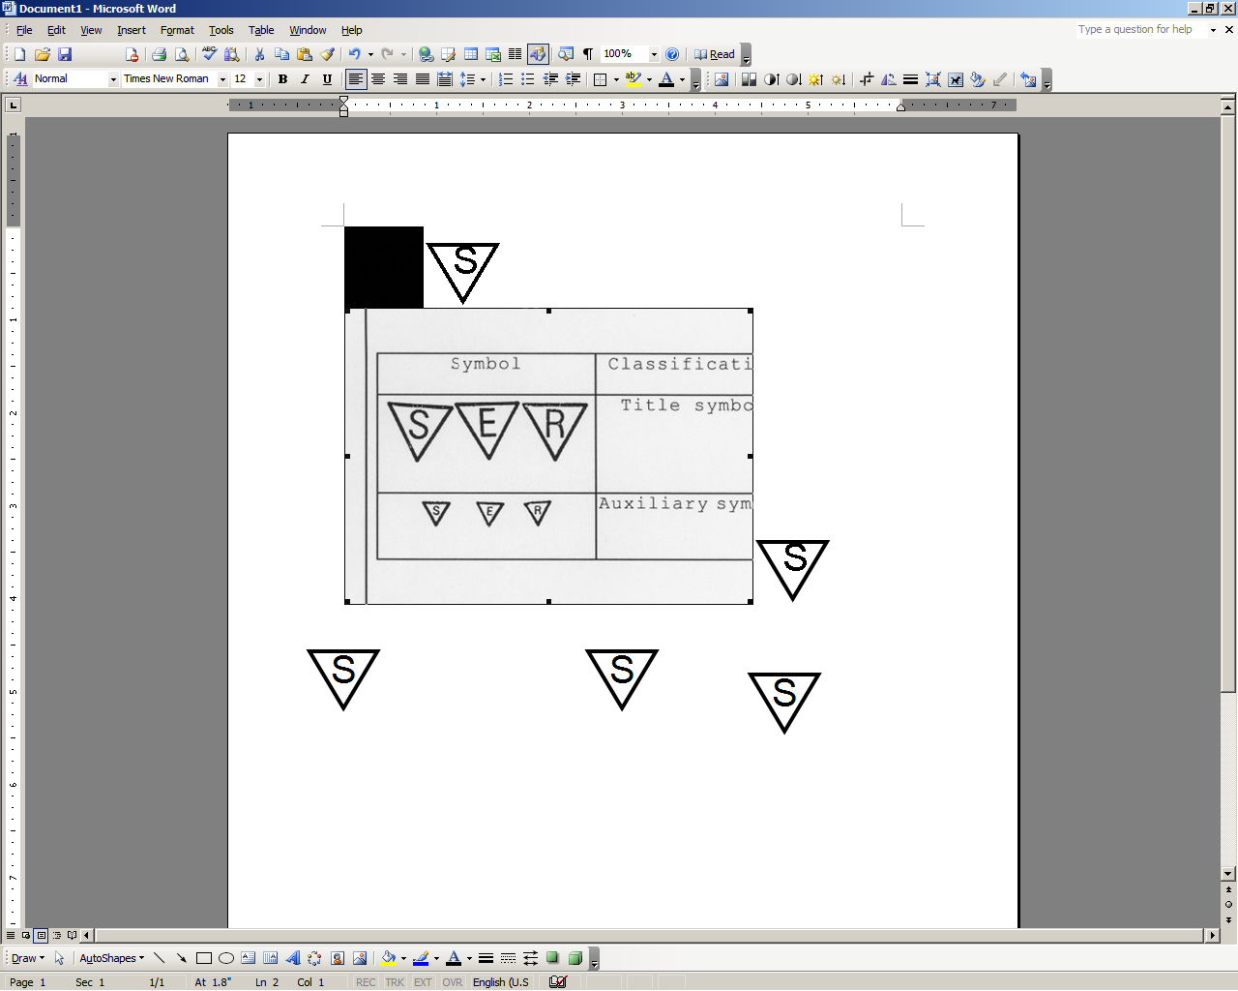

**STOP:** Damage to the vehicle may occur. Do not proceed until process has been complied with.

**OPERATOR SAFETY:** Use caution to avoid risk of injury.

**CAUTION:** A process that must be carefully observed in order to reduce the risk of damage to the accessory/vehicle and to ensure a quality installation.

**TOOLS & EQUIPMENT:** Used in Figures calls out the specific tools and equipment recommended for this process.

**REVISION MARK:** This mark highlights a change in installation with respect to previous issue.  
  
**SAFETY TORQUE:** This mark indicates that torque is related to safety.



Supplier ref # PT90848080-INST

Your Sienna All Weather Mats have been designed to fit the ideal 2nd and 3rd row seating positions. In order to move the 2nd row seat forward or rearward, you may need to temporarily adjust or remove the all-weather mats.

7-pass_fixed or no consoleAWM_ID

7-pass_sliding console8-pass_Fixed Console

Accessory Function Checks

Removal of all existing floor mats - Visual

Proper retention of All Weather Floor Mats

Alignment - Visual

Vehicle Function Checks

Accelerator pedal operation

**WARNING: Do not stack mats on top of existing mats**

Vehicle Appearance Check

After accessory installation and removal of protective cover(s), perform a visual inspection.

Rubber or carpet floor mats prior to install.

Ensure front driver mat grommets are installed on retention posts and the turn lock has been rotated to secure mat

Mats to fit properly in vehicle

Ensure installed mats do not interfere with accelerator pedal operation

Ensure no damage (including scuffs and scratches) was caused during the installation process.

(For PPO installations, refer to TMS Accessory Quality Shipping Standard.)

Supplier ref # 5INS061610TA